**CS590BD BIG DATA ANALYSIS**

**LAB 4**

**Step 1:**

* *After clicking reterive push button file will be saved in the defined location(sdcard),*

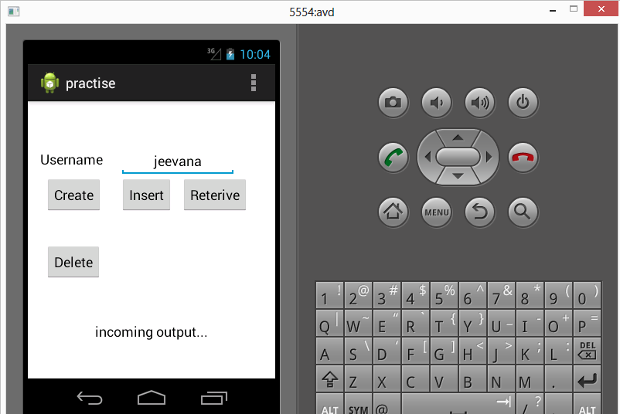

*Here we have created 4 text files same process followed as lab2 .*

* ***Training files*** *: LeftToRightj.txt , RightToLeft.txt , BTPJ.txt*
* ***Testing file*** *: TestFile.txt*

***Copy the these files and save them on cloudera***

***/home/group6***

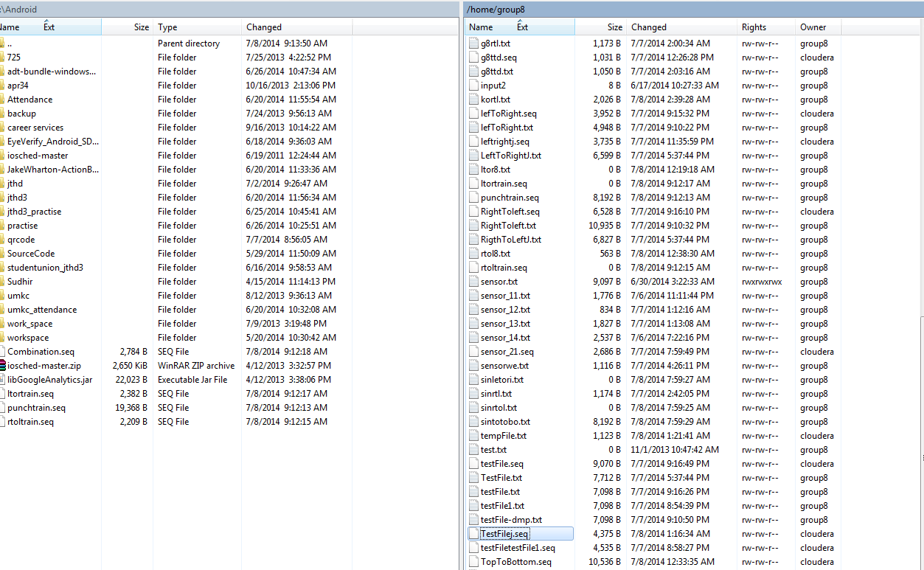

* After that we are converting txt files to sequence file by calling below servive
* [http://134.193.136.147:8080/HMMWS/jaxrs/generic/TrainFileOperation/-home-group6-LeftToRightJ.txt/-home-group6-leftrightj.seq](http://134.193.136.147:8080/HMMWS/jaxrs/generic/TrainFileOperation/-home-group6-LeftToRightJ.txt/-home-group6-leftrightj.seq%20%20)

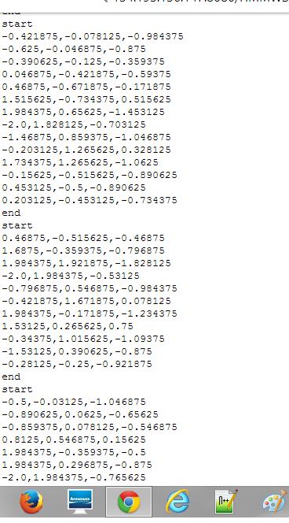

***Generating RightToLeft.seq***



* ***Generating BTPJ.seq***

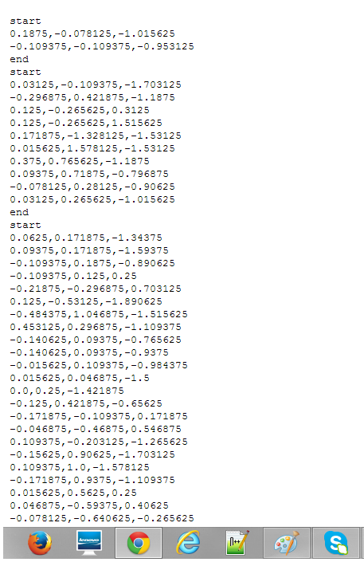

* ***Generating TestFilej.seq***

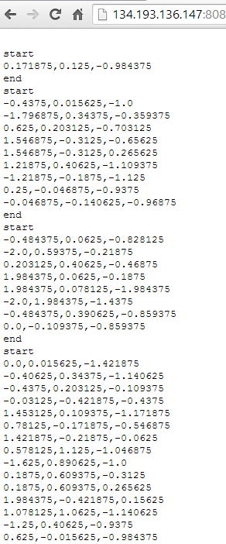

***Step 2: Training and testing for activity recognition***

*As we have set of sequence files for training and testing , now we have to run below service using our generated sequence files to identify whether training got success and generates motions.*

[http://134.193.136.127:8080/HMMWS/jaxrs/generic/HMMTrainingTest/-home-group6-leftrightj.seq/-home-group6-RightToLeft.seq/-home-group6-BTPJ.seq/-home-group6-TestFilej.seq](http://134.193.136.127:8080/HMMWS/jaxrs/generic/HMMTrainingTest/-home-group6-leftrightj.seq/-home-group6-RightToLeft.seq/-home-group6-BTPJ.seq/-home-group6-TestFilej.seq%20%20)